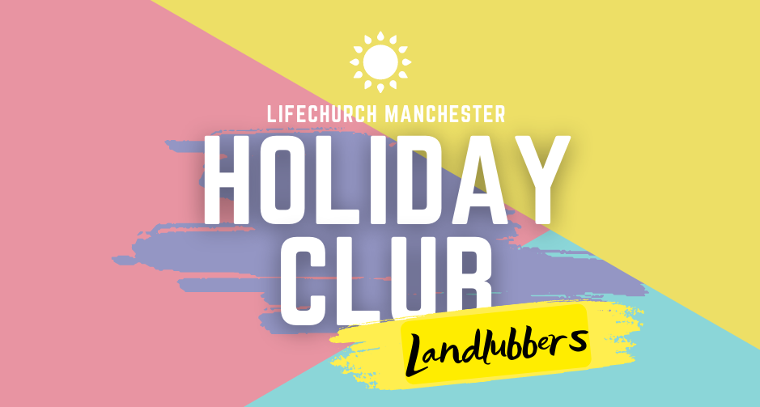
Mon 30/05-Wed 1/06
Holiday Club Registration Form
Please use this form to book a place for your child,
(We will never pass your Information on to anyone else.)
Name of child—

Date of Birth—

Male / Female—

Parent/Guardian Details—

Name—

Phone number—

Address—

Email Address—

General Consent—

“I give permission for my son/daughter to attend Holiday club held and operated by the team at LifeChurch, Manchester. Under the parameters set within this consent form and risk assessment, I allow the team to act as guardians during LifeKids events.”

Signed:

Date:

Photo & video—
This part of the consent relates to video and photos. If you would be happy for your child to be included in any group photos or videos then please also sign below .

I give permission for my child/ children to be included in photographs and videos which will be used for promotional use only.

Signed:

Date:
Your child’s name will never be used in conjunction with their picture but pictures and videos may be used on social media to publicise LifeKids events.
Medical Consent—

Does your son/daughter require regular medical treatment? - YES / NO If YES please give details...

Does your son/daughter have any allergies (ie plasters, aspirin, food etc)? - YES / NO If YES please give details...

“In the unlikely event of illness or accident I give permission for any necessary medical treatment to be given by the nominated first aider. In an emergency and if I cannot be contacted, I am willing for my child to receive hospital treatment – inc. general anaesthetics and emergency dentistry if necessary. I understand that every effort will be made to contact me on the above details but priority will be the safety and wellbeing of the child concerned.”

Signed:

Date:

Is there any further information you wish to tell us about your child?

-------------------------------------------------------------------------------------------------------------------------------- I give permission for my details to be entered on the LifeKids database.
(This is so we can notify you about future events) Yes/No

To guarantee your child’s place please fill in and return the form to nicko@lifechurch.uk.net

